**COMSATS University Islamabad,   
Abbottabad Campus**

**Project Proposal   
(SCOPE DOCUMENT)**

**for**

**< Medical Store-Distributor-Consumer Network >**  
Version 1.0

***By***

**Abdullah Iqbal CIIT/FA17-BSE-030/ATD**

**Armaghan Hasan CIIT/FA17-BSE-045/ATD**

**Majid Durrani CIIT/FA17-BSE-021/ATD**

***Supervisor*KASHIF NASIR**

***Bachelor of Science in Computer Science (2017-2021)***

|  |  |  |
| --- | --- | --- |
| **No.** | **Comment** | **Action** |
| V.1 | N/A | Writing the document |
|  |  |  |
|  |  |  |
|  |  |  |
|  |  |  |
|  |  |  |

**SCOPE DOCUMENT REVSION HISTORY**

**Supervisor Signature**

**Date:**

**Table of Contents**

**1.** **Introduction 4**

**2.** **Problem Statement 5**

**3.** **Problem Solution for Proposed System 5**

**4.** **Related System Analysis/Literature Review 5**

**5.** **Advantages/Benefits of Proposed System 5**

**6.** **Scope 6**

**7.** **Modules 6**

7.1 Module 1: Module Name 6

7.2 Module 2: Module Name 6

**8.** **System Limitations/Constraints 6**

**9.** **Software Process Methodology 6**

**10.** **Tools and Technologies 7**

**11.** **Project Stakeholders and Roles 7**

**12.** **Team Members Individual Tasks/Work Division 8**

**13.** **Data Gathering Approach 8**

**14.** **Concepts 8**

**15.** **Gantt chart 9**

**16.** **Mockups 10**

**17.** **Conclusion 11**

**18.** **References 11**

**19.** **Plaragism Report 11**

**Project Category: (**Select all the major domains of proposed project**)**

* **A-**Desktop Application/Information System **B-**Web Application/Web Application based Information System **C-** Problem Solving and Artificial Intelligence ** D-**Simulation and Modellingv ** E-** Smartphone Application ** F-** Smartphone Game ** G-** Networks ** H-** Image Processing****Other (specify category) ______________________

**Abstract**

This Website will maintain and track medicine stock inventory detail, will also help in generating and to maintain the billing records. This website will also help the shop keeper to automatically place the order with the Pharmaceutical companies and will help the person to track its shipment.

**Introduction**

The MSDCN is a medicine [stock inventory system](https://meeraacademy.com/inventory-management-system-in-c-asp-net/) used in medical store and Pharmaceutical companies. This website stores detail of medicine purchase stock and sell stock. We can maintain purchase stock detail by company wise sell stock detail by customer. This software automated generate bill for every selling and generate reports for stock, sell, and customer detail. This website will also help the shopkeeper to automatically place the order if the stock is short from the shop and will be able to track his shipment.

**Problem Statement**

In the age of digitization medical stores are still depends upon the paperwork. Sometime the store owner forgets to place order for medicines and sometimes medicine providers misplace the orders or deliver orders late, because of this, medical stores face’s problem of shortage. Sometimes even the person from the shopkeepers forgets to place the order if they are having the shortage. Even the hospitals face the same situation.

**Problem Solution for Proposed System**

To solve the problem of missing order, misplacing order or forget to place the order, our system will monitor the inventory and order the products if they are less in quantity or out of stock, automatically to the Pharmaceutical companies.

**Related System Analysis/Literature Review**

**Table 1 Related System Analysis with proposed project solution**

|  |  |  |
| --- | --- | --- |
| **Application Name** | **Weakness** | **Proposed Project Solution** |
| **Medical Point of Sale** | Point of Sale is on local and yet there is no backup and recovery options | Point of Sale will be online, have a centralized database with backup and recovery options |
| **Medical Inventory Management** | Inventory Management is on local and have no backup and recovery | Inventory Management will be online and have backup and recovery options |

**Advantages/Benefits of Proposed System**

**Advantages:**

* Prevention of Order Misplace.
* Prevention of Order Delay
* Tracking of Delayed Order
* Proper and Advance Inventory Management.
* Maintains records of Bills generated by point of sale.
* Maintains record of transactions and order made between Medical Store and Pharmaceutical Companies.
* Prevention of shortage of medicines with the help of Automatic Order placement.
* Report generation at the end of day, week, month, year.

**Scope**

Our system will target Medicine market. The problem with current medicine market is that all the communication, transactions, order placing, and order delivery is based on paper work and wire transfers which results in delays and no monitoring. Our system will provide online platform for both Medical Stores and Pharmaceutical Companies. It will allow them to monitor transaction, order details, order delivery status, point of sale details, inventory managements. Physical Order Delivery will not be covered by this system.

**Modules**

**Explanation of a Module:** Module is a section of a program that performs a task. Programs consist of [modules](http://www.webopedia.com/TERM/M/module.html), each of which contains one or more routines. The term routine is synonymous with procedure, function, and subroutine.

**Module 1: Inventory Management**

This module will allow user to perform different operation regarding inventory, such as update product price, update product quantity, add new product, delete product from inventory.

**Module 2: Point of Sale**

This module will calculate how much profit the medicine store has made, how many medicines are sold.

**Module 3: Automatic Order Placing**

This module will interact with Inventory Management System and monitor the product stock details and made automatic order to the medicine company.

**Module 4: Stock Availability**

This module checks that the stock is available in inventory. This module provides its functionalities to Medical Store View and Pharmaceutical Companies View.

**Module 5: Bill Generation**

The module will handle the process of bill generation for both customer buying medicines from medicine store and medicine store buying stock from companies.

**Module 6: Medical Store View**

This module will handle request and display interface accordingly to the Medicine Store.

**Module 7: Pharmaceutical Companies View**

This module will handle request and display interface accordingly to the Pharmaceutical Companies.

**Module 8: Report Generation**

This module will generate reports of product sold, profit made on daily, weekly, monthly and yearly bases for both medicine store and pharmaceutical companies.

**System Limitations/Constraints**

* Physical Delivery will not be responsibility of our system.
* Internet Connection is required to use the system.

**Software Process Methodology**

We are using **Iterative Model**. It begins with a basic operation of minimal needs and iteratively complements growing version till entire system is achieved and ready for setup.

**Tools and Technologies**

**Table 2Tools and Technologies for Proposed Project**

|  |  |  |  |
| --- | --- | --- | --- |
| **Tools**  **And**  **Technologies** | **Tools** | **Version** | **Rationale** |
| MS Visual Studio Code | 2020 (1.49) | IDE |
| MS SQL Server | 2015 | DBMS |
| Android Studio | 4.0.1 | Android App |
| MS Word | 365 | Documentation |
| MS Power Point | 365 | Presentation |
| Star UML | 3.2.2 | Design |
| MS Visio | 2013 | Design |
| Pencil | 2.0.5 | Mockups Creation |
| **Technology** | **Version** | **Rationale** |
| PHP/LARAVEL | 8.0 | Web Development |
| SQL | 2013 | Query Language |
| Bootstrap | 4 | Web Development |
| Java | 14 | Android App |
| **API’s** | **Version** | **Rationale** |
| Payments API | N/A | Online Transections |
| Email Login API | N/A | Accounts |
| Barcode API | N/A | Scanning Items |

**Project Stakeholders and Roles**

**Table 3Project Stakeholders for Proposed Project**

|  |  |
| --- | --- |
| **Project Sponsor** | COMSATS University, Islamabad |
| **Stakeholder** | * Retailer * Pharmaceutical Companies CEO * Employees of Pharmaceutical Companies  1. Accounts 2. Inventory 3. Delivery 4. Order Reciever |

**Team Members Individual Tasks/Work Division**

**Table 4Team Member Work Division for Proposed Project**

|  |  |  |
| --- | --- | --- |
| **Student Name** | **Student Registration Number** | **Responsibility/ Modules** |
| **Abdullah Iqbal** | **FA17-BSE-030** | * Module 1 * Module 5 * Module 8 * Android App * Database * Documentation * Testing |
| **Armaghan Hassan** | **FA17-BSE-045** | * Module 2 * Module 4 * Module 7 * Android App * Database * Documentation * Testing |
| **Majid Durani** | **FA17-BSE-021** | * Module 3 * Module 6 * Android App * Database * Documentation * Testing |

**Data Gathering Approach**

We are gathering requirements through **interview**. And Few requirements are also gathered through **questioners**. We have conducted **interview** of Retailer and Employees of Pharmaceutical company.

**Concepts**

*Concept-1: LARAVEL*

We will learn php Laravel MVC framework to develop our system on web based.

***Concept-2: Android***

We will learn Android to develop Android App for our system.

***Concept-3: Iterative Development***

We will learn Iterative Development to develop the system in iterative.

***Concept-4: Client – Server Architecture***

We will learn Client – Server Architecture in order to understand how our system will work, how android app communicate with the server.

**Gantt chart**

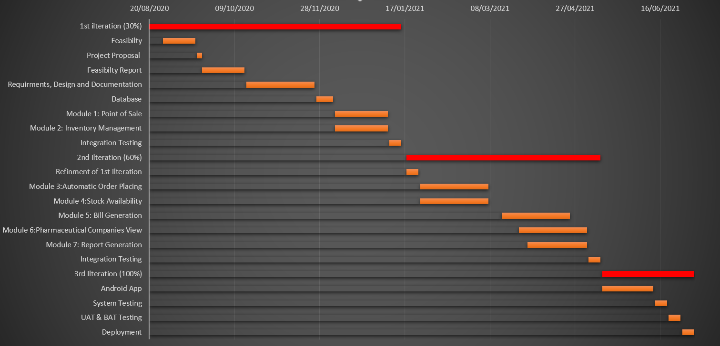

**Mockups**

1. Graphical user interface, table

   Description automatically generated**Dashboard Desktop Mockup**

Figure 1 Dashboard Desktop Mockup

1. Graphical user interface, application, email

   Description automatically generated**Add Items Desktop Mockup**
2. Table, calendar

   Description automatically generated**Product Desktop Mockup**
3. A screenshot of a cell phone screen with text

   Description automatically generated**Dashboard Mobile Mockup**
4. Graphical user interface

   Description automatically generated**Report Mobile Mockup**
5. **Sales Mobile Mockup**

**Conclusion**

Conclude this document. (Usually 4-5 sentences)

**References**

Mention the books, research papers, web links etc.

**Plagiarism Report**

Attach the Plagiarism report of your project scope document from library staff of turnitin tool (http://turnitin.com